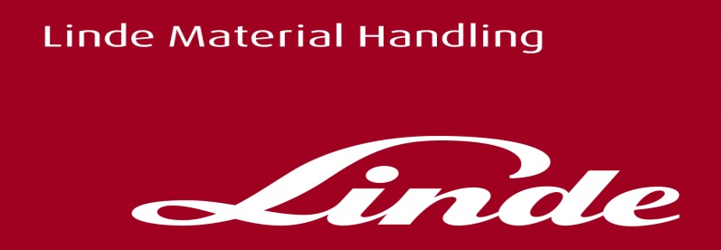

Press Release.

Linde Material Handling secures new flagship premises in the North West

Leading materials handling manufacturer Linde Material Handling UK Ltd are celebrating the opening of a new premises in Warrington, designed to become the flagship customer experience centre for the region.

The 12,000 square foot facility, which is now home to the regional team in the North West, is fitted out with a dedicated Fork Truck Training area and product demonstration areas for both New and Used materials handling equipment.

Craig Williamson, Senior Director for the North West region commented “The new building is something we are all incredibly proud of. Having all these facilities under one roof will enable us to provide a ‘one stop shop’ for our customers and grow our market presence in the North West.”

Linde Material Handling GmbH
Linde Material Handling GmbH, a KION Group company, is a globally operating manufacturer of forklift trucks and warehouse trucks, and a solutions and service provider for intralogistics. With a sales and service network that spans more than 100 countries, the company is represented in all major regions around the world.

Press contact:
Golley Slater
chodges@golleyslater.co.uk
07384 547118

